**Contents**

Introduction……………………………………………………………………….

Members………………………………………………………………….

Main Work Screenshots…………………………………………………….

Conclusion………………………………………………………………………….

## 

## **INTRO**

***With the help of agile mythology, we create an android application on Diary App. In this app, person can maintain his/her personal diary note in authorized manner. Person has to pick his/her user name and password by registering and use the app for maintaining his/her daily diary.***

# **Group Members**

**1.Amandeep Singh**

**2.Amritpal Singh**

**3.Gurvinder Singh**

Home Screen:

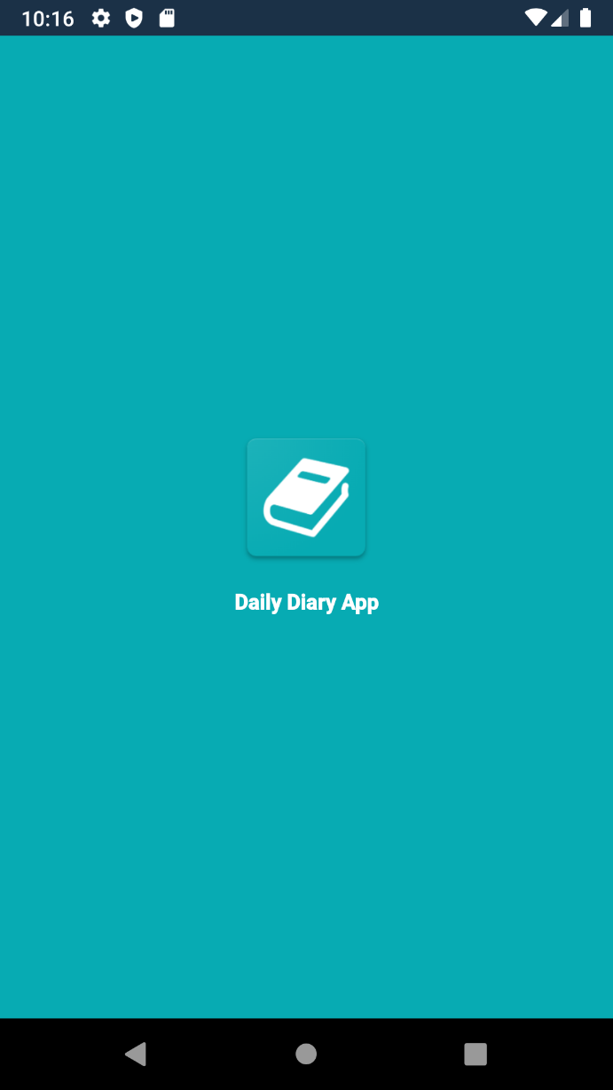

Login Screen:

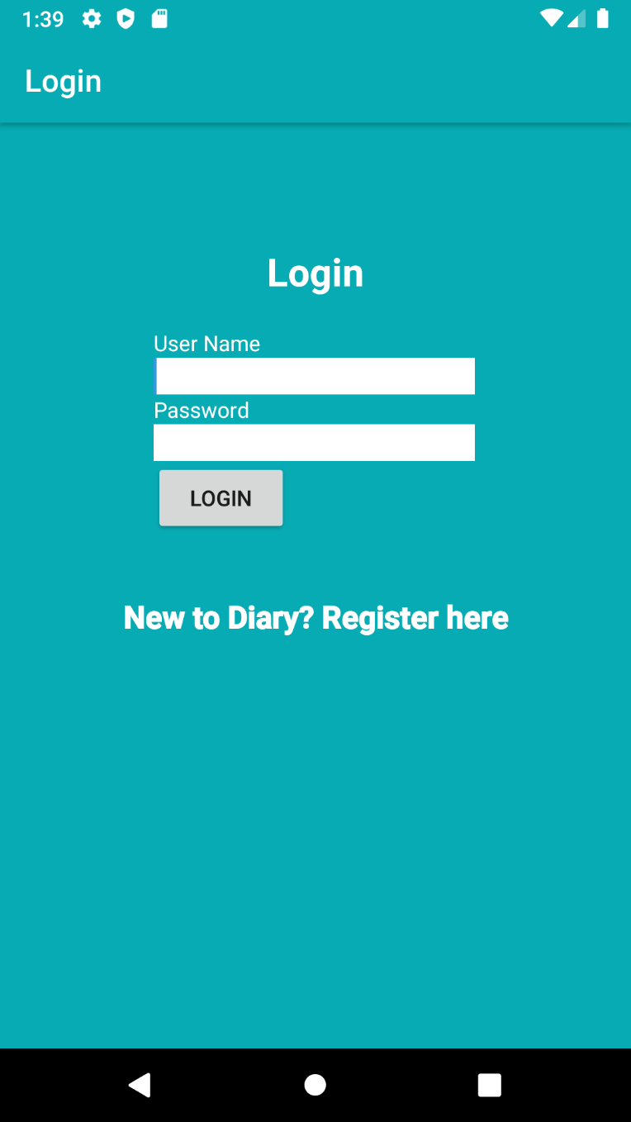

Register Screen:

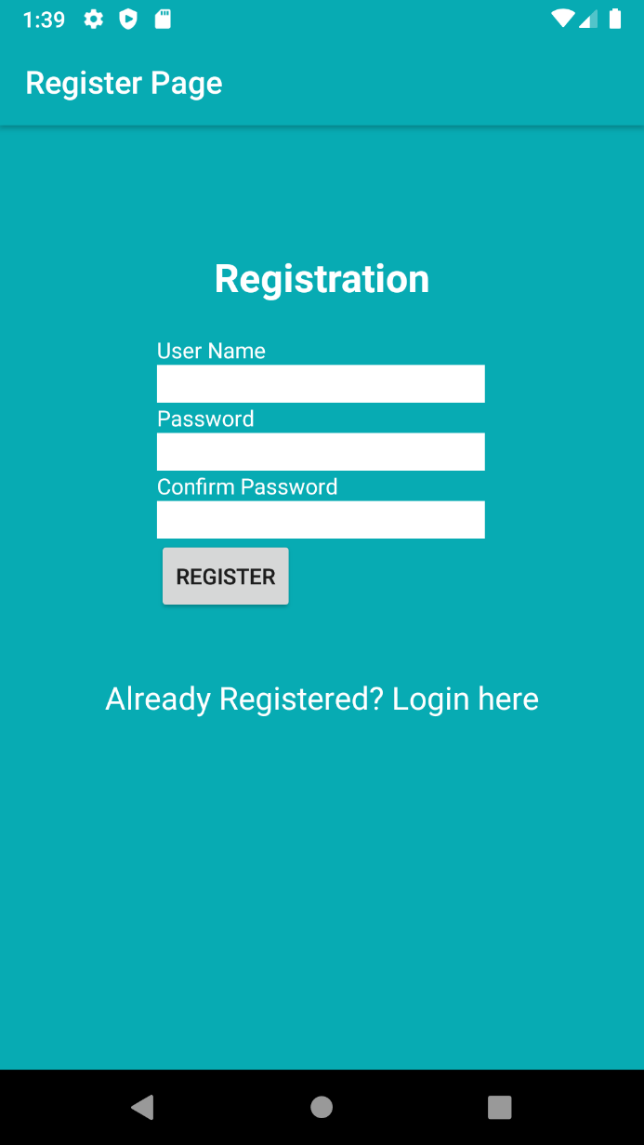

User Home Screen:

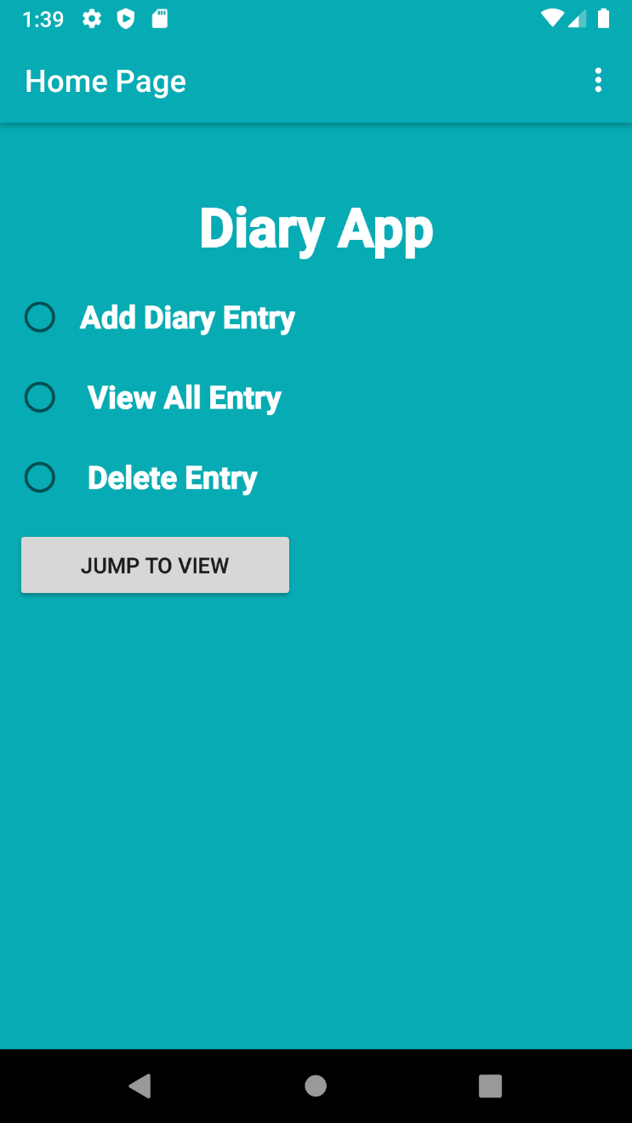

Add Diary Entry:

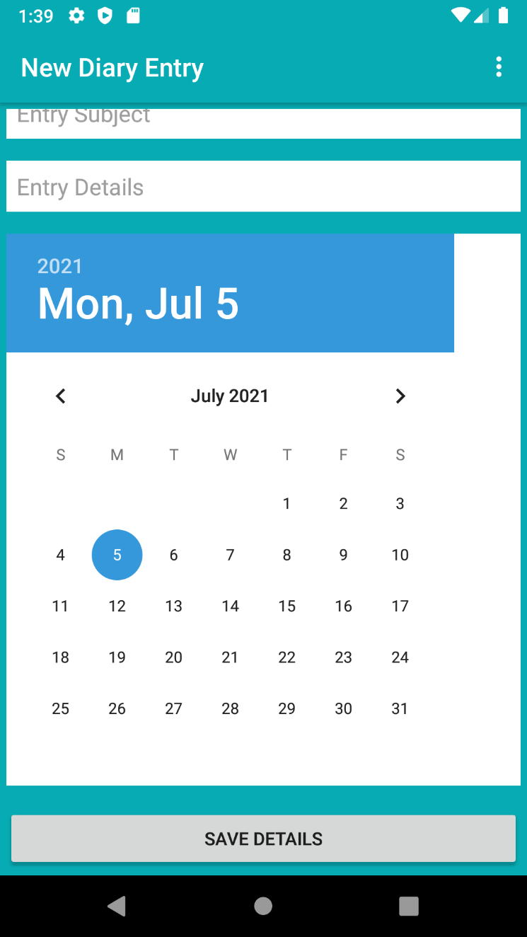

Context Menu Screen:

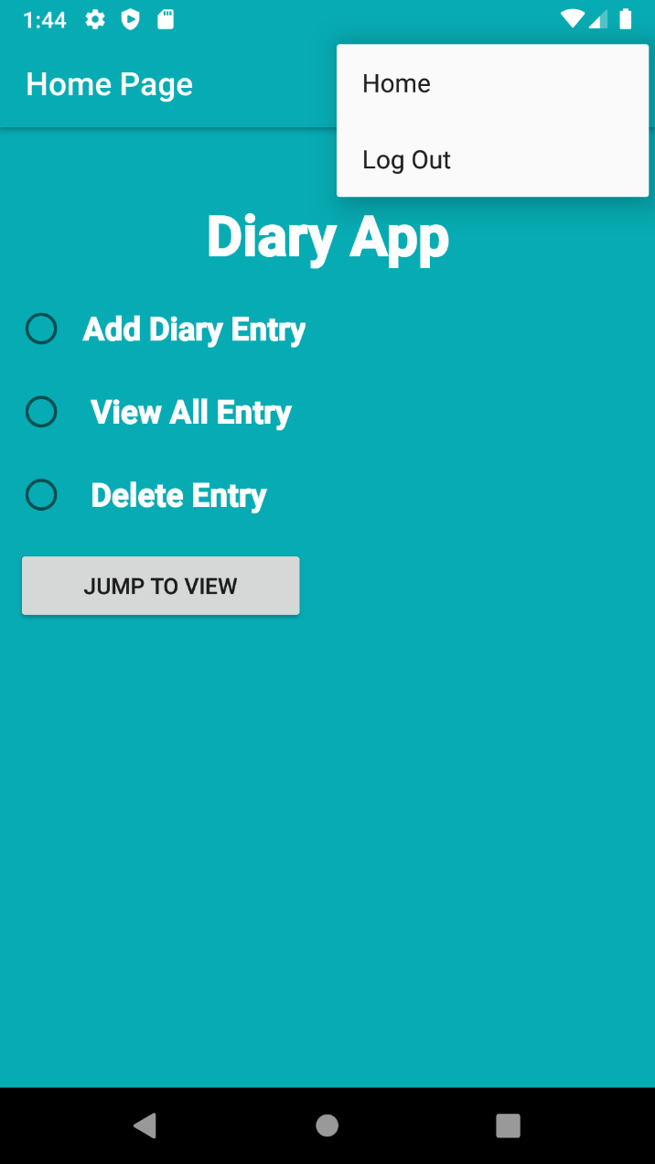

## **Conclusion**

***Agile and scrum methodology are used by the project managers for keeping the track of work. As it quickly reacts to changes and is more flexible as compared to others.***

***To sum up, this application is for the user to register their details and enjoy his/her personal diary in his/her phone memory.***